### A REPORT

**ON**

**POWER PLANT THERMAL EFFICIENCY IMPROVEMENT**

**BY**

**NAME: ID:**

MUDIT SRIVASTAVA 2018A3PS0430G

SIDDHARTHA JEJURKAR 2018A3PS0617G

**AT**

**VIKRAM CEMENT WORKS, NEEMUCH**

**A Practice School-I station of**



**BIRLA INSTITUTE OF TECHNOLOGY & SCIENCE, PILANI**

### A REPORT

**ON**

**POWER PLANT THERMAL EFFICIENCY IMPROVEMENT BY**

**NAME: ID: DISCIPLINE:**

MUDIT SRIVASTAVA SIDDHARTHA JEJURKAR

2018A3PS0430G B.E.(Hons) E.E.E.

2018A3PS0617G B.E.(Hons) E.E.E.

**Prepared in partial fulfilment of the Practice School-I Course Nos.**

**BITS C221/BITS C231/BITS241**

**AT**

**VIKRAM CEMENT WORKS, NEEMUCH**

A Practice School-I station of



**BIRLA INSTITUTE OF TECHNOLOGY & SCIENCE, PILANI**

# Acknowledgement

We would like to use this opportunity to express our gratitude to everyone who has been supporting us through the course of the project. Firstly, we are extremely grateful to our institute, BITS Pilani for offering us the course, Practice School – I during these testing times and giving us an opportunity to get an industry- based experience. Secondly, we would like to thank our instructor in-charge, Prof. Ankur Bhattacharjee to guide us and help us to get the utmost of this experience. Also, the mentors of our PS station, Vikram Cement Works Mr. Praveen Vijayvargiya to regularly guide us in our project. We would also like to thank everyone else who was directly or indirectly involved to provide us with this opportunity.

**BIRLA INSTITUTE OF TECHNOLOGY AND SCIENCE PILANI (RAJASTHAN)**

**Practice School Division**

**Station**: Vikram Cement Works

**Centre**: Neemuch

**Duration**: 6 weeks **Date of Start:** May 18, 2020 **Date of Submission**: June 6, 2020

**Title of the Project**: Power Plant Thermal Efficiency Improvement

**NAME: ID: DISCIPLINE:**

Mudit Srivastava 2018A3PS0430G BE (Hons.) E.E.E.

Siddhartha Jejurkar

2018A3PS0617G BE (Hons.) E.E.E.

**Expert Details :**

**Name :** Mr. Praveen Vijayvargiya

**Designation:** Vikram Cement Works , Neemuch

**Name of the PS Faculty**: Dr. Ankur Bhattacharje

**Abstract:**

A thermal power station may be a power plant during which the first cause is steam driven. Water is heated, turns into steam and spins a turbine which drives an electrical generator. After it passes through the turbine, the steam is condensed during a condenser and recycled to where it had been heated; this is often referred to as a Rankine cycle. The greatest variation within the design of thermal power stations is thanks to the various fuel sources. Some like better to use the term energy center because such facilities convert sorts of heat into electricity. Some thermal power plants also deliver heat for industrial purposes, for district heating, or for desalination of water also as delivering electric power. A large a part of human CO2 emissions comes from fossil fueled thermal power plants; efforts to scale back these outputs are various and widespread. At present 54.09% or 93918.38 MW (Data Source CEA, as on 31/03/2011) of total electricity production in India is from Coal Based Thermal power plant. A coal based thermal power station converts the energy of the coal into electricity. This is achieved by raising the steam within the boilers, expanding it through the turbine and coupling the turbines to the generators which converts energy into electricity.

**Signature(s) of Student(s): Signature of PS Faculty:**

**Date: Date:**

**INDEX**

##### Introduction

1. Thermal Power Generation Plant 2.1.What is Thermal Power Plant? 2.2.How does Thermal Power Plant work?

##### Concept behind Thermal Power Station

* 1. Theory of Thermal Power Plant
  2. Line diagram of Power Plant
  3. Advantages and Disadvantages of Thermal Power Plant

1. Power Plant Cycles
   1. Types of Power Plant Cycles
2. Rankine Cycle
   1. Typical Ideal Rankine Cycle
   2. Reheat Cycle
      1. Advantages of Reheat Cycle
      2. Disadvantages of Reheat Cycle
   3. Regenerative Cycle
      1. Advantages of Regenerative Cycle
      2. Disadvantages of Regenerative Cycle

##### Efficiency of Thermal Power Plants

1. Overview of TPP Performance Improvement Report
   1. Plant Overview
   2. How ABB conducted the study
   3. Conclusion based on the study
2. Conclusion
3. References
4. Glossary

**Introduction**

Almost all coal, nuclear, geothermal, solar thermal electric, and waste incineration plants, also as many gas power plants are thermal. The initially developed reciprocating external-combustion engine has been wont to produce mechanical power since the 18th Century, with notable improvements being made by Watt. When the first commercially developed central electrical power, stations were established in 1882 at Pearl Street Station in Ny and Holborn Viaduct power station in London, reciprocating steam engines were used.

The development of the turbine in 1884 provided larger and more efficient machine designs for central generating stations. By 1892 the turbine was considered a much better alternative to reciprocating engines; turbines offered higher speeds, more compact machinery, and stable speed regulation allowing simultaneous operation of generators on a common bus. After about 1905, turbines entirely replaced reciprocating engines in large central power stations.

THERMAL POWER GENERATION IN INDIA:

Thermal power plants convert energy rich fuel into electricity and heat. Possible fuels include coal, gas, petroleum products, agricultural waste and domestic trash / waste. Coal and lignite accounted for about 70% of India's installed capacity. India's electricity sector consumes about 80% of the coal produced within the country. A large a part of Indian coal reserve is analogous to Gondwana coal. The installed capacity of Thermal Power in India, as of June 30, 2011, was 115649.48 MW which is 65.34% of total installed capacity. The state of Maharashtra is that the largest producer of thermal power within the country.

**Thermal Power Generation Plant**

Thermal power generation plant or thermal station is that the most conventional source of electrical power. Thermal station is additionally referred as coal thermal station and turbine station.

As a matter of fact, Thermal Power Plants constitute 75.43% of the entire installed captive and non-captive power generation in India. Before going into detail of this subject, allow us to understand how does an influence plant work.

**What is Thermal Power Plant?**

*“Thermal power plant****”*** *as the title infers is the place of mechanism which converts heat energy into electric power.*

Thermal Power Plants also called Thermal Power Generation Plant or Thermal Power Station**.**

## How does Thermal Power Plant work?

In thermal power plants, the warmth energy obtained from combustion of solid fuel (mostly coal) is employed to convert water into steam, this steam is at air mass and temperature.

This steam is employed to rotate the turbine blade turbine shaft is connected to the generator. The generator converts the kinetic energy of the turbine impeller into electric energy.

# Concept behind Thermal Power Station

### Theory of Thermal Power Plant

The theory of thermal power plant or working of thermal power plant is extremely simple. an influence generation plant mainly consists of alternator runs with help of turbine. The steam is obtained from high pressure boilers. Generally, in India, soft coal, coal and peat are used as fuel of boiler. The soft coal is employed as boiler fuel has volatile matter from 8 to 33% and ash content 5 to 16%. to extend the thermal efficiency, the coal is employed within the boiler in powder form.

In coal thermal powerhouse, the steam is produced in air mass within

the boiler thanks to burning of fuel (pulverized coal) in boiler furnaces. This steam is further supper heated during a superheater. This superheated steam then enters into the turbine and rotates the turbine blades. The turbine is mechanically so including alternator that its rotor will rotate with the rotation of turbine blades. After entering in turbine, the steam pressure suddenly falls and corresponding volume of the steam increases.

After imparting energy to the turbine rotor, the steam passes out of the turbine blades into the condenser. within the condenser, the cold water is circulated with the assistance of a pump which condenses the low-pressure wet steam. This condensed water is further supplied to a low-pressure storage tank which acts as water heater where the low-pressure steam increases the temperature of this feed water; it's again heated in high pressure.

For better understanding we furnish every step of function of a thermal power station as follows,

1. First the pulverized coal is burnt into the furnace of steam boiler.
2. High pressure steam is produced in the boiler.
3. This steam is then passed through the super heater, where it further heated up.
4. This supper heated steam is then entered into a turbine at high speed.
5. In turbine this steam force rotates the turbine blades that means here in the turbine the stored potential energy of the high-pressured steam is converted into mechanical energy.

**Line Diagram of Power Plant**

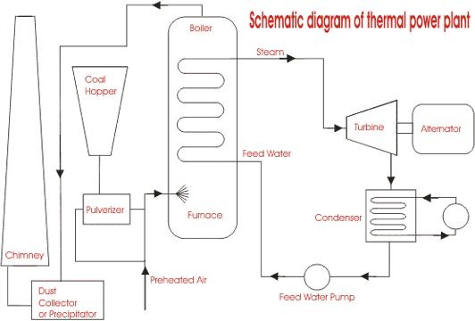

1. After rotating the turbine blades, the steam has lost its high pressure, passes out of turbine blades and enters into a condenser.
2. In the condenser the cold water is circulated with help of pump which condenses the low-pressure wet steam.
3. This condensed water is then further supplied to low pressure water heater where the low-pressure steam increases the temperature of this feed water, it is then again heated in a high-pressure heater where the high pressure of steam is used for heating.
4. The turbine in thermal power station acts as a prime mover of the alternator.

## Advantages and Disadvantages of Thermal Power Plant

Advantages:

1. Economical for low initial cost other than any generating plant.
2. Land required less than hydro power plant.
3. Since coal is main fuel and its cost is quite cheap than petrol/diesel so generation cost is economical.
4. Maintenance is easier.
5. Thermal power plant can be installed in any location where transportation and bulk of water are available.

Disadvantages:

1. The running cost for a thermal power station is comparatively high due to fuel, maintenance etc.
2. Large amount of smoke causes air pollution. The thermal power station is responsible for Global warming.
3. The heated water that comes from thermal power plant has an adverse effect on the aquatic lives in the water and disturbs the ecology.
4. Overall efficiency of thermal power plant is low like less 30%.

## POWER PLANT CYCLES

A thermal power plant works on the principle that heat is released by burning fuel which produces (working fluid) (steam) from water. The steam so produced runs the turbine coupled to generator which produces electricity.

A working fluid goes through a repetitive cycle change and this cyclic change involving heat and work is understood as thermodynamic cycle. Thus, a thermodynamic cycle may be a series of operations, involving a heat source, a heat receiver, a machine and dealing substance.

#### Types of Power Plant Cycles

Thermal power plants, in general, may work on Vapour and Gas Power cycles

Vapour Power cycles can be classified as:

* 1. Rankine cycle
  2. Reheat cycle
  3. Regenerative cycle
  4. Binary vapour cycle

Gas Power Cycle can be classified as follows:

1. Otto cycle
2. Diesel cycle
3. Dual combustion cycle
4. Gas turbine cycle

#### Rankine Cycle

Rankine cycle is the notional cycle on which steam power station works. Rankine cycle is a vapour-liquid cycle, it is most convenient to draw it on both the P-V and T-s diagrams with respect to the saturated-liquid and vapour lines of the working fluid, which usually but not always is water.

Figure shows a simplified flow diagram of a Rankine cycle.

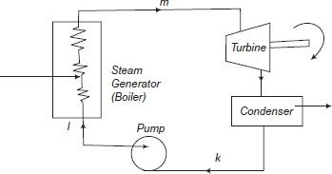

P-V diagram is shown in Figure.

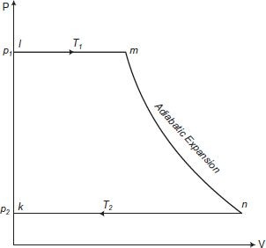

1. Operation (k-l): Condensed steam at pressure p2 and temperature T2 which is pumped into the boiler by means of feed pump at pressure p1 and there it is called temperature T1.
2. Operation (l-m): The hot water at a saturation temperature T1 is evaporated to steam at pressure p1.
3. Operation (m-n): After coming out of the boiler, the steam enters the turbine and expands adiabatically to a pressure p2.
4. Operation (n-k): The steam expands and condenses to water within the condenser at an equivalent temperature and is at pressure p2. Thus, the cycle is completed. This condensed water is again pumped to the boiler and then the next cycle starts.

#### Typical Ideal Rankine Cycle

In a vapor cycle if the working fluid during a vapor cycle passes through various components of the facility plant without irreversibility and frictional pressure drop, then the cycle is called as Ideal Rankine Cycle.

**Reheat cycle**:

A further improvement in cycle efficiency with gaseous primary fluids as in fuel and gas-cooled power plants is achieved.

The improvement in thermal efficiency thanks to reheat greatly depends on the reheat pressure with reference to the first pressure of steam.

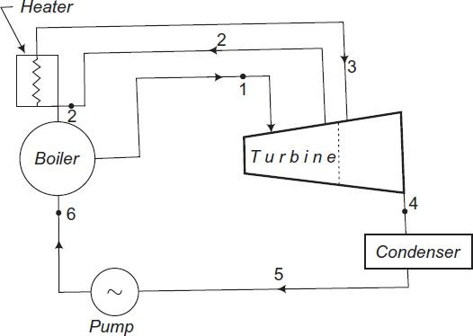

The corresponding representation of ideal reheating process on T-s is shown in the next Figure. It shows the formation of steam in the boiler. The steam at state point

1 (i.e., pressure p1 and temperature T1) enters the turbine an expands isentropically to a certain pressure p2 and temperature T2. From this state point 2 the entire of steam is drawn out of the turbine and is reheated during a reheater to a temperature T3.

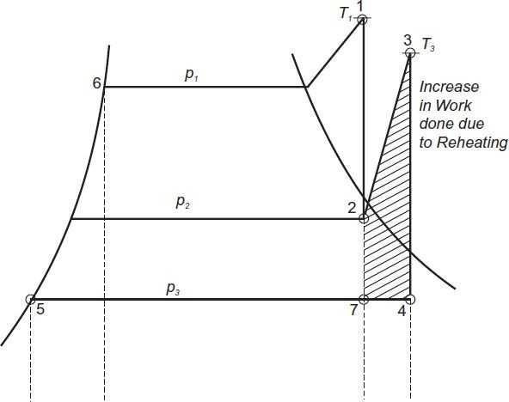

This reheated steam is then readmitted to the turbine where it's expanded to condenser pressure isentropically. Reheat allows heat addition twice. It leads to increasing the typical temperature at which heat is added and keeps the boiler hot, which ends up in improvement in cycle efficiency. Reheating also results in drier steam at turbine exhaust which is beneficial for real cycles.

Advantages of Reheating

1. there's an increased output of the turbine.
2. The thermal efficiency of the turbines increases.
3. Efficiencies of nozzle and blade increase.
4. Corrosion problems are minimised in steam turbines.
5. Dryness factor of steam improved.

Disadvantages of Reheating

1. Reheating requires maintenance.
2. Reheating increases the expenditure.

### Regenerative Cycle:

In the Rankine cycle it's observed that the condensate which is fairly at coldness has an irreversible mixing with hot boiler water and this leads to the decrease of cycle efficiency. Methods are, therefore, adopted to heat the feed water from the recent well of condenser irreversibly by interchange of warmth within the system and thus improving the cycle efficiency. This heating method is named regenerative feed heat and therefore the cycle is named regenerative cycle.

The principle of generation is often practically utilised by extracting steam from the turbine at several locations and supplying it to the regenerative heaters. The resulting cycle is understood as regenerative or bleeding cycle.

The heating arrangement comprises:

1. for medium capacity turbine — less than 3 heaters;
2. for top pressure high capacity turbines — less than 5 to 7 heaters; and
3. for turbines of supercritical parameters—8 to 9 heaters. The most advantageous condensate heating temperature is chosen counting on the turbine throttle conditions and this determines the number of heaters to be used.

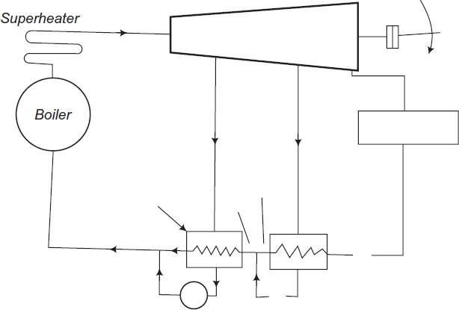

Figure shows a diagrammatic layout of a condensing steam power plant in which a surface condenser is used to condense all the steam that is not extracted by feed water heating. The turbine is double extracting and therefore the boiler is provided with a superheater. This arrangement constitutes a regenerative cycle. The condensate from the bled steam is then added to feed water.

Advantages of Regenerative Cycle Over Simple Rankine Cycle

1. The heating process within the boiler tends to become reversible.
2. The thermal stresses found out within the boiler are minimised. This is thanks to the very fact that temperature ranges within the boiler are reduced.
3. The thermal efficiency is improved because the typical temperature of warmth addition to the cycle is increased.
4. Heat rate is reduced.
5. The blade height is a smaller amount thanks to the reduced amount of steam skilled the low stages.
6. thanks to many extractions there's an improvement within the turbine drainage and it reduces erosion thanks to moisture.
7. A small size condenser is required.

Disadvantages of Regenerative Cycle Over Simple Rankine Cycle

1. The plant becomes more complicated.
2. Maintenance cost is more.
3. an outsized capacity boiler is required for a given power rating.
4. the warmers are costly and therefore the gain in thermal efficiency isn't much as compared to the prices.

# EFFICIENCY OF THERMAL POWER PLANTS

Overall efficiency of a thermal power plant is calculated as the ratio of heat equivalent of electric power and heat produced due to fuel combustion in the furnace.



Although many factors affect the heat transfer cycle and efficiency, the major ones are :

###### Boiler Efficiency :

Depends on the heat content of the outlet steam and the heat provided by combustion of fuel. Incomplete combustion can lead to excess impurities and decreased efficiency. A typical steam boiler has an efficiency of 85%

###### Cycle Efficiency :

The overall thermodynamic cycle also affects the efficiency. Since the thermal power plants use a Rankine cycle with steam/water as the working fluid, loss of heat content which is expelled from the steam turbine affects the efficiency significantly.

###### Turbine Efficiency :

This is the efficiency of a turbine to convert heat energy carried by steam from boiler into useful mechanical energy.

###### Generator Efficiency :

Generator efficiency is calculated using the mechanical energy input from the steam turbine and the actual energy output generated. A typical generator has an efficiency of 96-99%.

A typical Thermal Power Plant efficiency is quite low. Generally, it ranges between 25 to 30%, and in extremely rare cases it is 40%.

A thermal power plant operation resembles a Rankine cycle, hence increasing the temperature of steam from the boiler or decreasing the temperature of cooling liquid in the condenser increases the overall efficiency of the plant

Industries usually take steps to implement this, few of which are:

1. Energy output generated by the generator has a high dependence on the pressure and temperature of steam entering the turbine chamber. Higher the temperature and pressure more is the power generated. This is the main reason why steam from the boiler is superheated before it is sent to the steam turbine.
2. Exhaust steam from the turbine is sent back to the boiler through the BFP, but pressurizing steam is an expensive and difficult task. Hence it is first passed through a condenser where it is converted to low pressure water. This water has much less volume (nearly 1/17th times the original volume of steam) and is also easier to pressurize.

# OVERVIEW OF TPP PERFORMANCE IMPROVEMENT REPORT

We were provided an Opportunity Identification Report by the Industry mentor which detailed the current performance of the UTCL Vikram Cement Works Power Plant and identified opportunities for improvement and increasing efficiency. The report was based on a performance study conducted by ABB where plant performance data was recorded and analysed.

###### PLANT OVERVIEW

Major equipment used in the plant include :

* 2 Boilers
* 2 Turbines
* 1 Distributed Control System (DCS)

The plant uses CPP Boilers (Condensate Polishing Plants), that prevents steam condensate contaminants and corrosion products from entering the boiler or turbine. CPP Boilers in the plant are connected via a common header, but measurement of Common Header Steam Pressure is missing.

Main equipment used in each Boiler include:

* 1 ID fan (Induced Draft)
* 1 PA fan (Primary Air flow)
* 1 SA fan (Secondary Air flow)
* 4 Drag Chain Feeders
* 1 Limestone Screw Feeders
* 1 Bed Material Screw Feeder
* 2 CEP (Condensate Extraction Pumps)
* 5 CW (Cooling Water pumps)
* 6 ACC fans (Air Cooled Condenser fans)
* 3 BFP (Boiler Feed Pumps)

Fuel used in the Boiler combustion chamber is a combination of Pet Coke, Indian Coal and Lignite. The specifics of exact fuel composition and gross calorific value of each component is included in the Opportunity Identification Report

A few control loops used in the plant as mentioned in the performance report are:

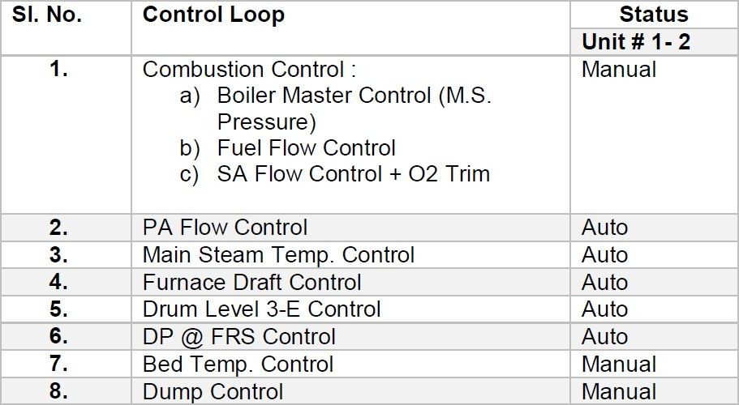

**HOW ABB CONDUCTED THE STUDY**

Before conducting a detailed study, a baseline for current plant performance was established. This was done to compare it against the new performance data that would be recorded after the suggested improvements were implemented. The baseline also helped in finding any deviations in design performance values for plant equipment and machinery.

ABB’s performance calculation software module was used to determine actual plant performance. The software assumes a fuel composition of 100%Pet Coke (with calorific value of 8182 kcal/kg), mixed with 30-40% limestone used as boiler feed. Control logic software was also used to track how present controls were configured.

The actual plant performance was then recorded for 2 different units of the plant to establish a baseline.

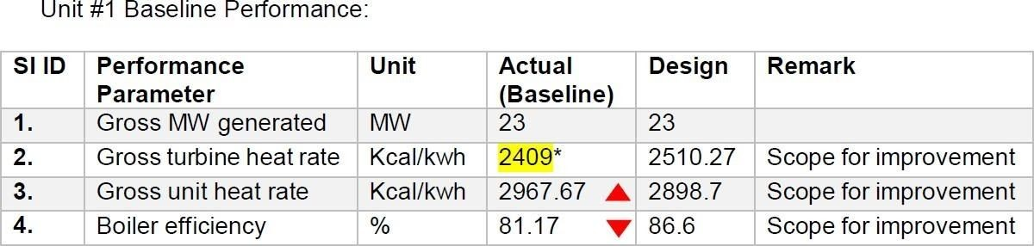

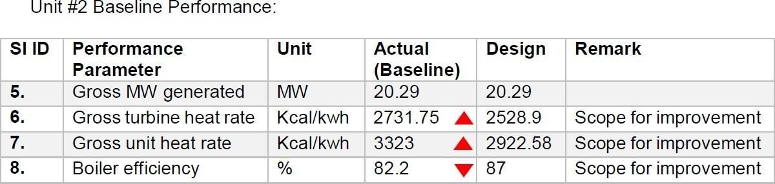

This baseline was first compared with the set design parameters and then with actual data that was collected during site visit.

**CONCLUSION BASED ON THE STUDY :**

The performance report suggested over a dozen performance improvement opportunities for UTCL Vikram Cement Works Power Plant. The report also suggested improvements for few control logics along with their prospective benefits.

Estimated improvements of implementing suggested solutions are listed below:

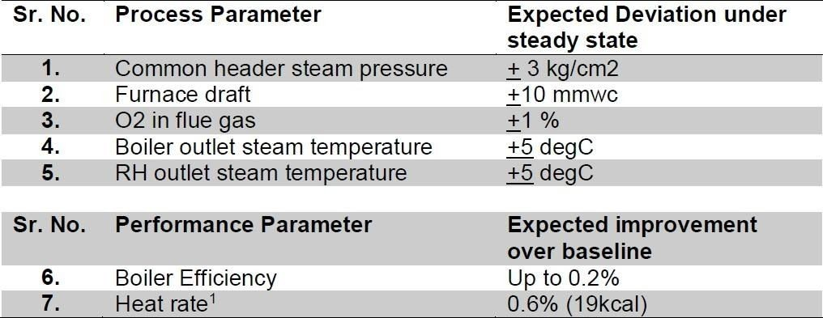

A few benefits of implementing suggested solutions include:

1. Improvement in heat rate due to reduction of fuel consumption per unit of energy
2. Increased Boiler efficiency due to combustion optimization
3. Faster equipment response to load disturbances
4. Reduction in energy consumption by equipment such as ACC fans.
5. Reduction in excess O2 consumption
6. Improved emission and operator efficiency

The entire opportunities overview is provided in the Opportunity Identification Report

# CONCLUSION

This report presents our study and the progress made on the project Thermal Power Plants : Efficiency improvement. Till now the basics of thermodynamic cycles have been covered with a specific focus on the Rankine Cycle and how it is used for power generation in Thermal Power plants. A general overview of Thermal Power Plants and their operation has also been provided, along with the factors that determine its overall efficiency and how it can be improved.

The lack of an actual industrial visit and exposure is compensated by the analysis of the Power Plant performance report which was provided by our Industry Mentor. The report provided the required data which was recorded during an actual site visit and also identified various opportunities for improving the plant performance.

The report summarizes our entire progress and presents certain findings which are essential for accomplishing future tasks that are necessary for the completion of the project.

## References

* [**https://www.electrical4u.com/thermal-power-generation-plant-or- thermal-power-station/**](https://www.electrical4u.com/thermal-power-generation-plant-or-thermal-power-station/)
* [**http://www.thermodyneboilers.com/components-working-thermal- power- plant/#:~:text=How%20does%20Thermal%20Power%20Plant%20wor k**](http://www.thermodyneboilers.com/components-working-thermal-power-plant/)

[**%3F,is%20connected%20to%20the%20generator**](http://www.thermodyneboilers.com/components-working-thermal-power-plant/)

* [**https://www.electrical4u.com/rankine-cycle/**](https://www.electrical4u.com/rankine-cycle/)
* [**https://www.youtube.com/watch?v=IdPTuwKEfmA&t=208s**](https://www.youtube.com/watch?v=IdPTuwKEfmA&amp;amp%3Bt=208s)
* Ultratech, Vikram Cement Works. “Power Plant Performance Improvement, Opportunity Identification Report*”*.

**Glossary**

ACC fans: Air Cooled Condenser fans BFP: Boiler Feed Pumps

CEP: Condensate Extraction Pump CPP: Condensate Polishing Plant CW: Cooling Water pump

DCS: Distributed Control System ID Fan: Induced Draft Fan

PA Fan: Primary Air flow fan SA Fan: Secondary Air flow fan

UTCL: Ultratech Cement Pvt. Ltd.